6))))The accompanying scatterplot shows the relationship between the percentage of teenagers who had used marijuana and the percentage of teenagers who had used other drugs in 11 countries. Summary statistics showed that the mean percent that had used marijuana was 23.5​%, with a standard deviation of 15.6​%. An average of 10.8​% of teens had used other​ drugs, with a standard deviation of 10.1​%. Complete parts a through e below.
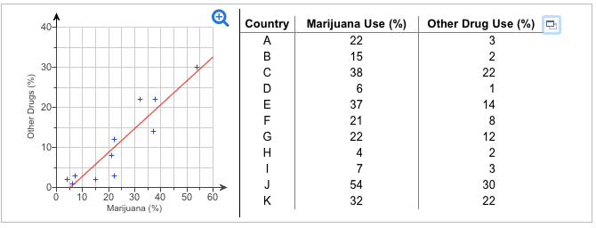
A)
Do you think a linear model is​ appropriate?
A.
Yes. The plot shows a​ positive, linear, fairly strong relationship.

B.
No. There are outliers in the plot.

C.
Yes. While the relationship is​ weak, there is no reason to think that the linear model is not appropriate.

D.
No. The plot shows a nonlinear pattern.

B)
For this​ regression,
R2 is 85.3​%. Interpret this statistic in this context, circle the right answer

The percentage of Marijuana/other drug (circle correct answer) use accounts for ____% ​(Type an integer or a​ decimal) of the variation in the percent use of Marijuana/other drug (circle correct answer)
c) Write the equation you would use to estimate the percentage of teens who use Other Drugs from the percentage who have used Marijuana.

​(Round to three decimal places as​ needed.)

D)Explain in context what the slope of this line means. circle the right answers and fill in the blank

The slope indicates that marijuana/other drug use​ increases, on​ average, by ____ for each percent increase in marijuana use/other drug use.
​(Round to three decimal places as​ needed.)

E)
Do these results confirm that marijuana is a​ "gateway drug," that​ is, that marijuana use leads to the use of other​ drugs?
A.
Since the value of Upper R2 is​ large, the results confirm that marijuana leads to other drug use.

B.
Since the value of Upper R2 is​ small, the results do not indicate that marijuana leads to other drug use.

C.
The results indicate an association between marijuana and other drug​ use; however, association does not imply causation.

D.
The results do not show a strong association between marijuana and other drug use.

Question 8

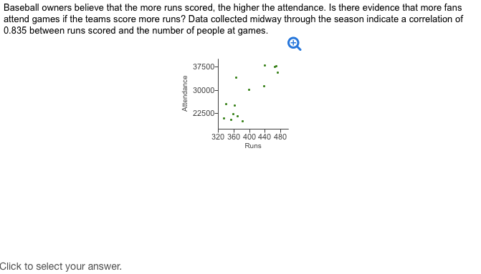

a) Does the scatterplot indicate that​ it's appropriate to calculate a​ correlation? Explain.
A.
​Yes, because the association between the number of runs scored and attendance is positive.

B.
​No, because there are too many outliers for a numerical correlation to be appropriate.

C.
​Yes, because the relationship between number of runs scored and attendance appears to be straight.

D.
​No, because the number of runs scored and attendance are not quantitative variables.

​b) Describe the association between attendance and runs scored.

A.
The association between attendance and runs scored is​ positive, straight, and moderate.

B.
The association between attendance and runs scored is​ positive, straight, and weak.

C.
The association between attendance and runs scored is​ negative, straight, and moderate.

D.
The association between attendance and runs scored is​ negative, straight, and strong.

​c) Does this prove that the owners are​ right, that more fans will come to games if the teams score more​ runs?

A.
​Yes, there is basis to make a claim of causation.

B.
​No, there is no basis to make a claim of causation.

C.
​No, there is no evidence of an association between attendance and runs scored.

D.
​Yes, there is evidence of an association between attendance and runs scored.

Question 9)

​

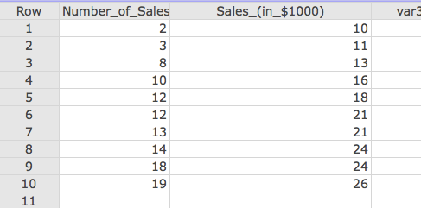

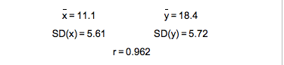

a) Find the slope​ estimate,
b1=____
​(Round to three decimal places as​ needed.)
​
b) What does this b1 value​ mean, in this​ context?

A.
It means​ that, on​ average, the number of sales people working is approximately b1 times 1000 multiplied by the total sales.
B.
It means​ that, on​ average, an additional increase of b1 times $ 1000 in sales is associated with each additional sales person working.
C.
It means​ that, on​ average, the total sales will equal
b1 times $ 1000 multiplied by the number of sales people working.
D.
It means​ that, on​ average, an additional increase of b1
times 1000 sales people working is associated with each additional dollar in sales.

​c) Find the​ intercept,
b0=____
​(Round to three decimal places as​ needed.)
​
d) What does this b0 value​ mean, in this​ context? Does this value of b0 make​ sense?

A.
It means​ that, on​ average, an additional increase of b0
times $ 1000 in sales is associated with each additional sales person working. It does not make​ sense, because the value of b0 is much larger than b1.
B.
It means​ that, on​ average, the expected sales is b0
times $ 1000 with 0 sales people working. It does not make​ sense, because it is unlikely that any sales would be made with zero sales people working.\
C.
It would mean​ that, on​ average, the minimum amount of sales made from 2 sales people working is b0 times $ 1000. It makes​ sense, because b0 is greater than zero.
D.
It means​ that, on​ average, the total sales will equal b0
times $ 1000 multiplied by the number of sales people working. It makes​ sense, because b0 is greater than zero.

f) If 17 people are​ working, what sales​ (in dollars) do you​ predict?

The predicted sales are=____$
​(Round to the nearest ten dollars as​ needed.)
​
g) If sales are actually ​$24​,000, what is the value of the​ residual?

residual=_______ dollar/s
​(Round to the nearest ten dollars as​ needed.)

​h) Has the original estimate from part f overestimated or underestimated the​ sales?
A)underestimated
B)overestimated
C)neither overestimated nor underestimated

